Kanorau Digital | Recruitment Resources & Info
Thank you for helping us to spread the word about the Kanorau Digital short course kaupapa!
This document outlines what we’d like your help with, and who we’re trying to reach. It also includes some suggested copy you could use to reach potential applicants and supporters.
The latest promotional images, PDF files and other recruitment collateral can be found here > http://bit.ly/KanorauDigitalRecruitment

What is Kanorau Digital?
Kanorau Digital is a foundation digital skills short course designed to help individuals who find the digital world a bit (or a lot) challenging. During this digital skills course, participants will gain the skills to get online safely and the know-how to navigate devices, websites and digital tools with more confidence. The short course is free (no course fees) and delivered at a variety times and most days of the week.
Te Wānanga o Aotearoa (TWoA) is delivering Kanorau Digital which is targeted to Māori and Pasifika (Sāmoa, Tonga, the Cook Islands, Niue, Tokelau, Tuvalu) communities in Aotearoa / New Zealand. The short course will be open to everyone to register for due to the TWoA’s values of inclusivity, although the target group for participants is Māori and Pasifika.

What does ‘Kanorau’ mean?
Kano means seed. Rau is many. Kanorau means to be diverse, varied, multicoloured.
In this short course, we’ll plant the seeds to help whānau and participants get the confidence to use digital devices and the internet as a tool to connect with our diverse world.

Here’s how the short course is structured?
- a variety of day and class time options to suit all learners
- 1-on-1 guidance with an experienced tutor
- access to WiFi and a laptop during class time
- access to online material to keep learning at home
- an online student community to support learning.

What is covered in the course?
Each course topic covers different learning areas and everyday digital skills.
- Topic 1: Introductions, emails, online calendars, sharing documents online and joining a group video call.
- Topic 2: Setting up online folders, using maps, saving files and photos.
- Topic 3: Using the internet to solve problems, searching online, finding useful websites.
- Topic 4: The different ways that ‘life’ can be done online. Being safe and keeping your important info secure when dealing with banking, shopping and other online business.

What can participants expect to learn?
- send and check emails using Gmail
- use Google Tools to create, organise, and connect with the digital world
- solve common problems using online resources
- explore day-to-day tasks such as online shopping and banking
- stay safe when they’re online.

Important Contact Info
Website: www.kanorau.nz
Free Phone: 0800 KANORAU (526 672)
Email: Kanorau@twoa.ac.nz
Facebook www.facebook.com/KanorauDigital - @KanorauDigital

Here are some ways you can help us reach potential applicants and champions:
- Post about the Kanorau Digital short course on your social media channels and online groups
- Include info about the Short Course in your next email newsletter or external communications
- Share links to the landing page – www.kanorua.nz - or content about this shot course to colleagues, partners and stakeholders or anyone you think should know about this kaupapa
- Mention the Short Course at any relevant meetings or events
- Handout the printed A4 flyers at relevant meetings or make them available for whānau to pick them up at your reception, foyer, waiting rooms, or community spaces. Email kanorau@twoa.ac.nz to request copies of the flyers
- Display the printed A2 posters in high-traffic areas where your community and visitor will see theme. It could be your reception, foyer, waiting rooms, classroom. Camus or community spaces. Email kanorau@twoa.ac.nz to request copies of the posters

Here’s who we’re trying to reach & what to say:
Potential Participants | Potential Influencers/Promoters
They are people… :  - that have a basic or limited understanding about technology, the internet, and online services  - without the knowledge and skills to connect to the internet with different devices in different ways  - with low trust and confidence with technology to carry out online activity and engage services  - Parents, grandparents and guardians that want to understand digital devices, online platforms etc that their kids are using and interacting with everyday | They are:  - Community support organisations.  - Local Govt or not for profit organisations.  - People connected with specific communities or networks  - Organisations that run events, are connected to digital skill programmes or have influence/interest in supporting digital learners
Suggested Copy / Messages:  Want to learn digital skills to make life easier? Let Kanorau Digital help you with that.  Have you got a mobile phone or tablet? Not sure how to work the thing? Let Kanorau Digital help you with that.  Are you lost when it comes to getting online? Let Kanorau Digital help you find your way in the digital world.  Want to be smarter your digital device? Let Kanorau Digital help you unlock the potential of your smart phone, tablet or computer.  Kanorau Digital is a free short course designed to help you get the confidence to use digital devices and the internet as a tool to connect with our diverse world.  Kanorau Digital is a free course to help you find your way in the digital world.  Classes running now until in <your area> or <insert location of course>. Sign up for your local course today. | Suggested Copy / Messages:  Do you know someone that struggles with working their mobile phone or digital device?  Then there’s the good stuff they’re missing out on - staying in touch with the kids and mokopuna, receiving messages and emails, taking pictures to share with others.  Some of our whānau are being left behind online. Could this be your mum or dad, aunty or grandparents or even, you?  Te Wānanga o Aotearoa is delivering a new short course to help close the digital divide. During the short course, they’ll learn how to connect online with the world.  If you know someone who finds the digital world a bit (or a lot) challenging - here’s a new free short course designed to help them get - and stay connected.  Help them keep up with technology by recommending Kanorau Digital. Once they’re on board, we’ll support and encourage them to gain the confidence to use digital devices and the internet to be connected to the world.  Kanorau Digital tutors will show them how to navigate websites, apps, Google documents and more, so they can make appointments, shop online and keep in touch with the kids.  No fees for this short course.
Call to action: Find out more, and register!  Sign up today! | Call to action: Help us spread the word!
Contact Details: Call 0800 KANORAU (526 672) to sign up or ask someone to help you register at www.kanorau.nz | Contact Details: Learn more at www.kanorau.nz or talk to our team on 0800 KANORAU (526 672)  Get in touch with the Kanorau Digital Team to sign them up for our free short course. Visit www.kanorau.nz or call 0800 KANORAU (0800 526 672)

Sample Copy for Posts, Ads & Newsletters
Announcing new kaupapa post  Text:  Introducing.... KANORAU DIGITAL  Kanorau Digital is a free short course designed to help whānau get the confidence to use digital devices and the internet as a tool to connect with our diverse world. Ahikōmako is excited to host some of the first courses in our whare in November and December. Delivered by Te Wānanga o Aotearoa in partnership with Manaiakalani Education Trust, this kaupapa is helping to close the digital divide in Aotearoa.  ---  If you know someone that struggles with working their mobile phone or digital device, then there’s the good stuff they’re missing out on - staying in touch with the kids and mokopuna, receiving messages and emails, taking pictures to share with others. Help them keep up with technology by recommending Kanorau Digital in Hamilton. Learn more at www.kanorau.nz or talk to the team on 0800 KANORAU (526 672)  URL: https://www.facebook.com/ahikomako/posts/1384586131884735 | 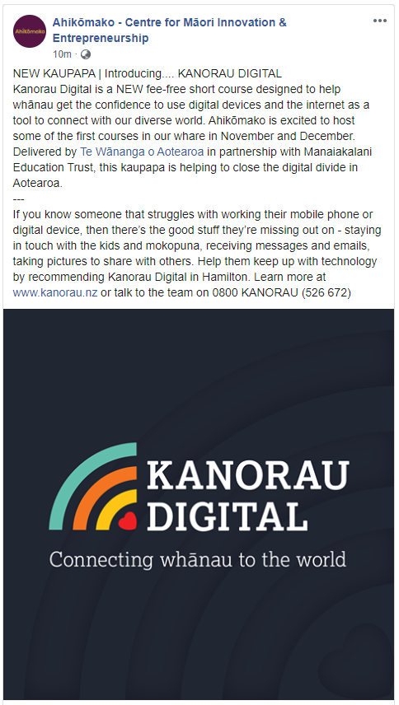
Community Supporter Post  Text:  Kanorau Digital launched this week. Ka rawe!  Congratulations to Te Wānanga o Aotearoa who worked collaboratively with a bunch of good sorts including Arataki Systems Lee Timutimu Nikora Ngaropo Julia Arnott-Neenee, Manaiakalani Education Trust and many others to bring this important programme to life ... and in under 4 months.  It's easy to come up with ideas, but much more challenging to make them happen.  We can't wait to see this mahi go from strength to strength, ensuring that no one is left behind in a digital world.  #digitalskills #digitalequity  www.kanorau.nz  Post: https://www.linkedin.com/posts/spark-foundation_kanorau-digital-activity-6732032364165263360-b6-Y | 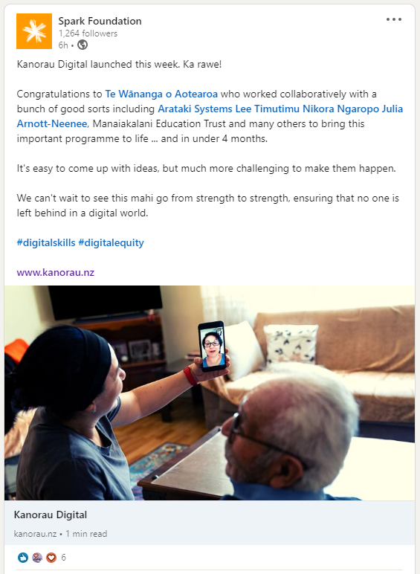

Recruitment Collateral, Assets and Resources

Video
Māori TV Commercials – Series of 4 videos for TV ad’s and uploaded on Youtube. Will be shared in Social Media and digital advertising (e.g. Youtube) soon
- Video 1: https://youtu.be/TUt_7MdQhWQ
- Video 2: https://youtu.be/VymdL4OxYYA
- Video 3: https://youtu.be/gPD5Efpvi2c
- Video 4: https://youtu.be/UheUsvA4WBQ

Social Media and Web Creative
Link to files > https://twoa-my.sharepoint.com/:f:/g/personal/aimee_burness_twoa_ac_nz/EiTFr8q_USpHjTMWfGSDb9MBfXBcLjEXc3A-auw3mjrXxQ?e=mz7BPP

Press Release
- Shared via Kanorau Digital FB page.... https://www.facebook.com/KanorauDigital/posts/110976727705202 Have a read and feel free to share with your social networks.
- hosted via the TWoA website if you would like to share the direct link with any connections and networks > https://www.twoa.ac.nz/hononga-stay-connected/news-events/2021/02/25/kanorau-digital-to-help-digitally-excluded-new-zealanders

Email Template
- Use this template to follow up queries or a templated response for private courses > https://twoa-my.sharepoint.com/:w:/g/personal/aimee_burness_twoa_ac_nz/Ebws4wKZwp9BqxguAp9lO2YBYRxJ6MtgcBHSIETSk6AZ5Q?e=0QAZof

Current Digital & Offline Marketing

Newspaper Adverts
- Sample ad & newspaper layout

Kanorau Digital Facebook & Instagram Ads
- Facebook Ads National – links to ads to be added
Third-Party Mobile Blast Advertising
- Stuff News App – Mobile Blast (Scheduled for 23 March 2021)
- Sample ads

Busbacks – Porirua City Route Only
- Sample artwork

Digital & Static Billboards
- Sample ads

Te Wānanga o Aotearoa - Homepage Carousel
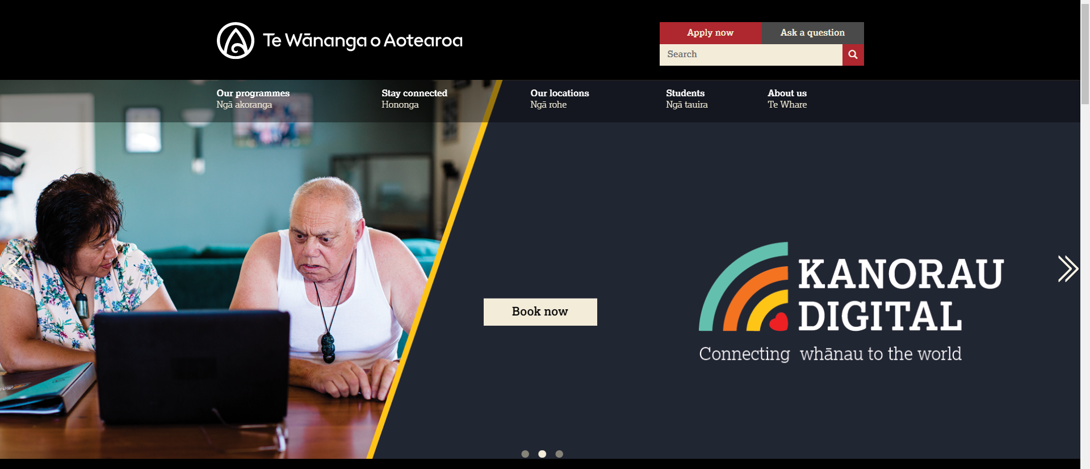

TWoA Digital Facebook & Instagram Ads
TWoA has pushed out the following digital ads for Kanorau Digital on Facebook and Instagram

Copy & Links | Ad
Ad 1 Copy:  Staying connected with whānau online is hard without digital skills. Learn how to make the most of your digital devices with our fee-free short course.  Facebook URL: https://www.facebook.com/17690633595/posts/10157789219138596  Instagram Ad: https://www.instagram.com/p/CHgx3_iD6S0/ | 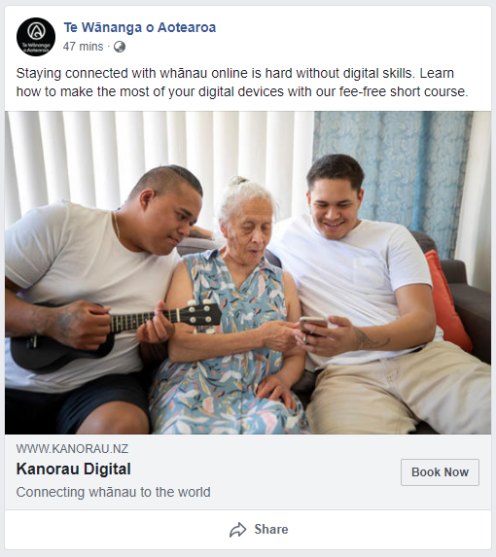
Ad 2 Copy:  Staying connected with whānau online is hard without digital skills. Learn how to make the most of your digital devices with our fee-free short course.  Facebook URL: https://www.facebook.com/17690633595/posts/10157789219203596  Instagram Ad: https://www.instagram.com/p/CHgx39wDyDn/ | 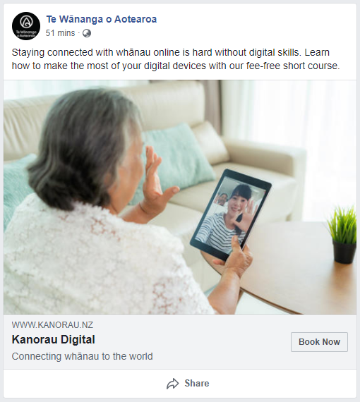
Ad 3 Copy:  Staying connected with whānau online is hard without digital skills. Learn how to make the most of your digital devices with our fee-free short course.  Facebook URL: https://www.facebook.com/17690633595/posts/10157789219153596  Instagram Ad: https://www.instagram.com/p/CHgx3-7jUht/ | 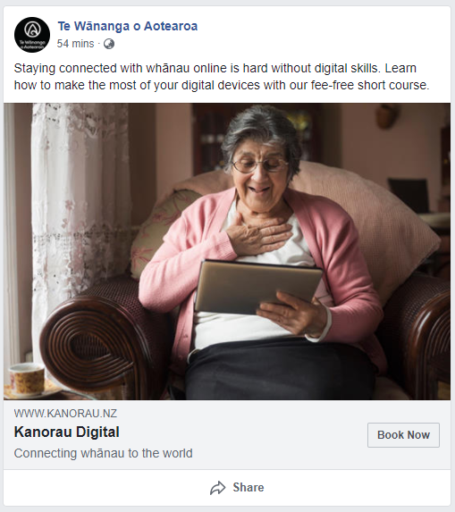
Ad 4 Copy:  Staying connected with whānau online is hard without digital skills. Learn how to make the most of your digital devices with our fee-free short course.  Facebook URL: https://www.facebook.com/17690633595/posts/10157789219193596  Instagram Ad: https://www.instagram.com/p/CHgx4BCjzTx/ | 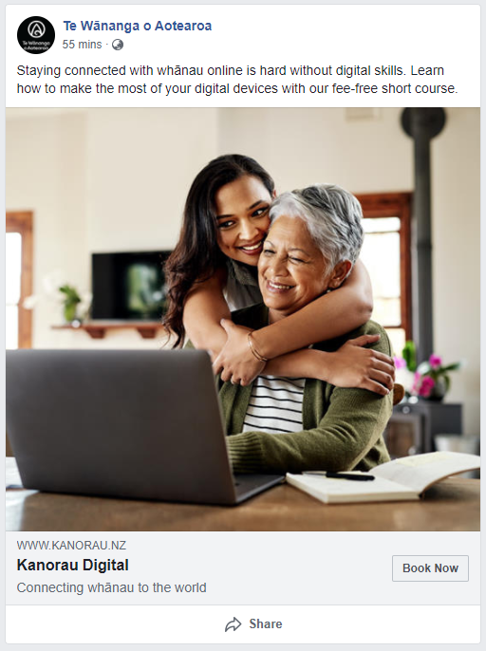
Ad 5 Copy:  Staying connected with whānau online is hard without digital skills. Learn how to make the most of your digital devices with our fee-free short course.  Facebook URL: https://www.facebook.com/17690633595/posts/10157789219438596  Instagram Ad: https://www.instagram.com/p/CHgx4mpjSs0/ | 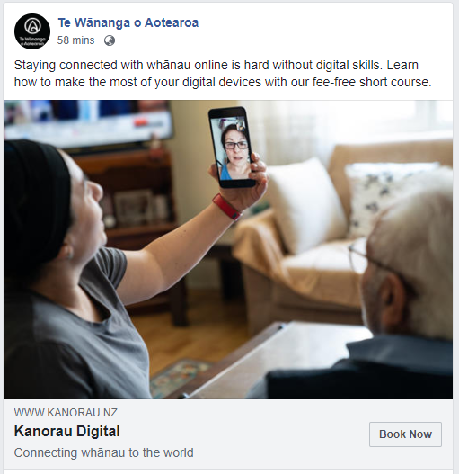
Ad 6 Copy:  Staying connected with whānau online is hard without digital skills. Learn how to make the most of your digital devices with our fee-free short course.  Facebook URL: https://www.facebook.com/17690633595/posts/10157789219518596  Instagram Ad: https://www.instagram.com/p/CHgx4pEjttn | 